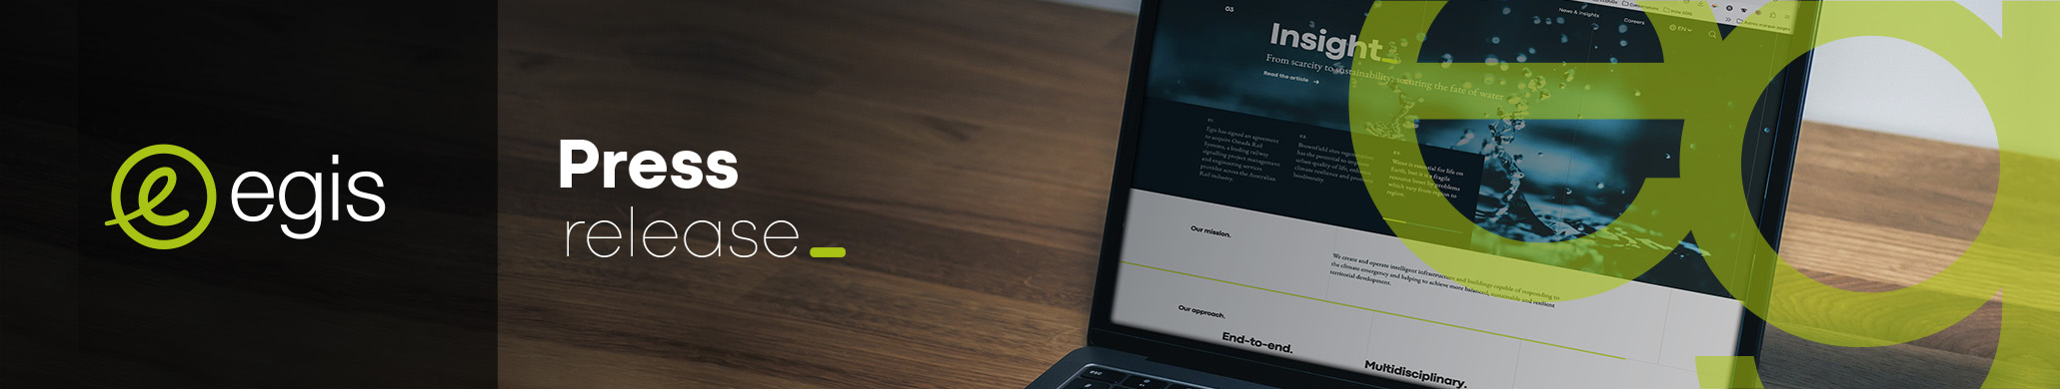
XX April, 2026

United Arab Emirates

Egis successfully concludes and delivers the expansion of Yas Waterworld on Yas Island, Abu Dhabi

Egis recently celebrated a significant milestone following the official opening of the latest expansion of Yas Waterworld Yas Island, Abu Dhabi. Appointed by Miral, the leading creator of immersive destinations and experiences in Abu Dhabi, the Egis Engineering team in the UAE served as Lead Design Consultant for the expansion of the region’s leading water park. The team coordinated multiple design disciplines, authority approvals and specialist sub-consultants, with a clear focus on delivering infrastructure that is resilient and intelligently integrated, supporting the award-winning theme park’s continued evolution and the enhancement of its overall offering.
Egis’ teams also delivered the integrated MEP design for the expansion, including above- and below-ground pump rooms, a new electrical substation, food and beverage outlets with supporting changing facilities, and all associated external utility networks. Just as importantly, Egis developed the technical strategy for interfacing these new systems with Yas Waterworld’s existing infrastructure, a critical piece of the project that demanded rigorous analysis, sound engineering judgement and close stakeholder coordination.
Dr Ali Amiri, Buildings Director, Egis Group, said: “The opening of Yas Waterworld’s latest expansion is a proud moment for our teams and a strong example of how Egis supports clients in delivering complex destination projects with confidence. What makes this project especially significant is that much of the value lies behind the scenes — in the engineering decisions, the coordination effort, the optimisation of existing assets and the quality of integration. Those are the elements that make an expansion perform successfully, safely and sustainably over time.”
Located at the south-east tip of the existing Yas Waterworld site, the expansion adds approximately 16,900 square metres of new facilities to a complex, high-footfall destination that remained live throughout the project. That context defined the challenge from the outset. This was not a standalone development on a blank site; it was a sophisticated expansion requiring new rides, amenities and utilities to be embedded into an existing operational environment with strict safety, access, theming and continuity requirements.
Rather than defaulting to new standalone infrastructure, Egis carried out detailed site surveys, desktop reviews of as-built information and analysis of BMS consumption data to assess the available capacity within the existing chilled water, water and power systems. The outcome was a technically robust and commercially astute solution. In a region where the retrofit and optimisation of existing assets is becoming increasingly important, the project demonstrates how engineering intelligence can unlock value that is both immediate and enduring.
Designing an expansion next to a live attraction is one challenge; enabling it to be constructed safely and efficiently is another altogether. Egis supported the planning of utility diversions, construction phasing and access arrangements so works could proceed with minimal disruption to ongoing operations and without compromising guest safety or visitor experience. The relocation strategy for existing 22kV and fibre optic cables, for example, required particularly careful coordination with authorities, the client and the operator to avoid material impact on the existing park.
The project incorporated demand-controlled ventilation, high-efficiency LED lighting, smart lighting controls, leak detection systems integrated with BMS, and a metering strategy for chilled water, potable water and power to support ongoing monitoring and operational optimisation. Local manufacturers were also recommended where compliant with project specifications, supporting regional supply chains while contributing to a lower overall carbon footprint.
Now open to guests, the Yas Waterworld expansion stands as a tangible demonstration of Egis’ ability to deliver high-value engineering within complex, live environments, and to do so in a way that supports the client’s broader vision for growth, experience and operational excellence.
About Egis
________________________________

Egis is a leading global architectural, consulting, construction engineering, operations and mobility services firm. We create and operate intelligent infrastructure and buildings that both respond to the climate emergency and contribute to balanced, sustainable and resilient development.

Our 23,500 employees operate across over 70 countries, deploying their expertise to develop and deliver cutting-edge innovations and solutions for clients. Through the wide range of our activities, we are central to the collective organisation of society and the living environment of citizens all over the world.

With over 4,000 employees across 8 countries in the Middle East, Egis has delivered over 700 complex development projects, stimulating economic growth and enhancing quality of life. Ranked among the top five firms in the Middle East by Engineering News Record (ENR), Egis is committed to sustainable development. The Group’s operations in the Middle East are built on strategic acquisitions and a deep understanding of local market conditions. Egis’ long history of providing comprehensive engineering, consulting, and project management services makes it a trusted partner for regional governments, investors, and developers.

LinkedIn: Egis | Instagram: @egisgroup | Facebook: @egisgroup
Press contacts
________________________________

Dana Rafeh  Marketing & Communications Director  Tel.: + 971 52 116 3767  dana.rafeh@egis-group.com   | Elena Jenkinson  Head of Communications and Marketing  Tel.: + 971 52 219 1042  elena.jenkinson@egis-group.com

