
March 14, 2025,

Mexico City, Mexico

Breaking Barriers: Women Driving the Future of Rail in Mexico
________________________________

At The Unreasonable & Unexpected to Reach the Extraordinary, Egis and the League of Railway Women promote female leadership in the railway industry.
The railway industry is undergoing transformation, and Egis is at the forefront of this change. During The Unreasonable & Unexpected to Reach the Extraordinary event, held on March 14 at Hacienda Los Morales, Egis and the League of Railway Women reaffirmed their commitment to inclusion, innovation, and female leadership in this key sector for mobility and sustainable development.
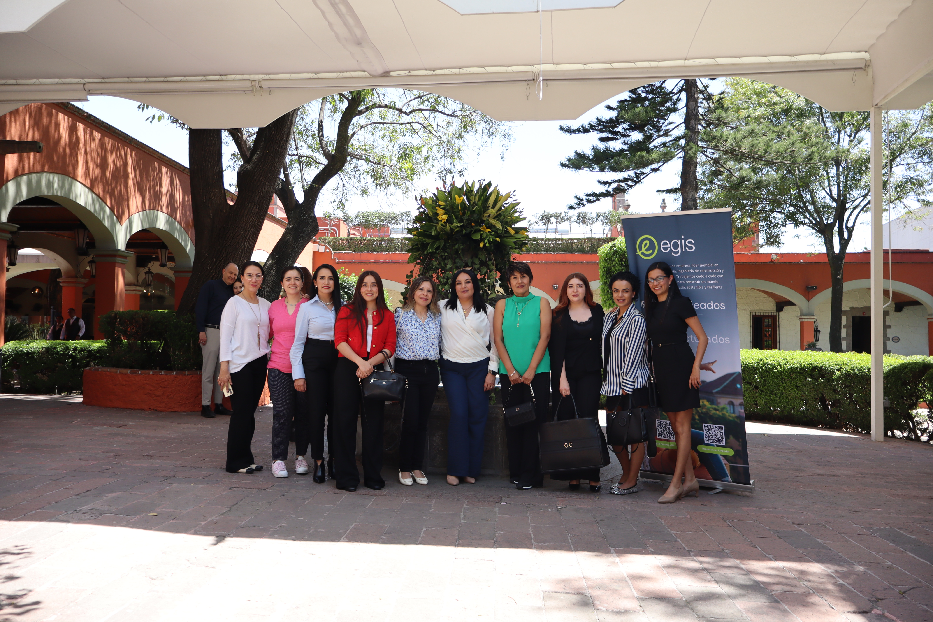
Linda Hernández, leader of the League of Railway Women and current Director of Industrial Development at CPKC Mexico, highlighted the crucial role of women in the railway sector and their impact on the industry’s evolution.
In this context, the League of Railway Women recognized Egis’s leadership by appointing Diana Rivero, Business Development Manager at Egis Mexico, as Co-Ambassador of the League in the country. This milestone reinforces Egis’s vision of creating a more inclusive, innovative, and efficient railway ecosystem.
Women Leading Railway Transformation
The event also highlighted the recent appointments of women who are redefining the sector:
- Geraldine López, AMF Communications Coordinator, as Co-Ambassador of the League in Mexico
- Alix Cruz, Operations Director at Ferrovalle
- Rocío Hernández, Logistics Director at Ferrovalle
- Vianey De la Mora, General Director of the Mexican Railway Association (AMF)
Francisco Fabila, President of the AMF, emphasized that the key is not only gender representation but also attracting the best talent and strengthening professional excellence in the sector.
Egis and Its Vision for Smart and Sustainable Railway Mobility
A key moment of the event was the presentation by Yudi Monterroso, an operations engineer at Egis Mexico, who underscored the importance of developing railway projects focused on smart mobility and social benefit.
Monterroso highlighted key innovations in urban mobility, such as:
- Cable cars as an efficient transportation solution in Mexico City
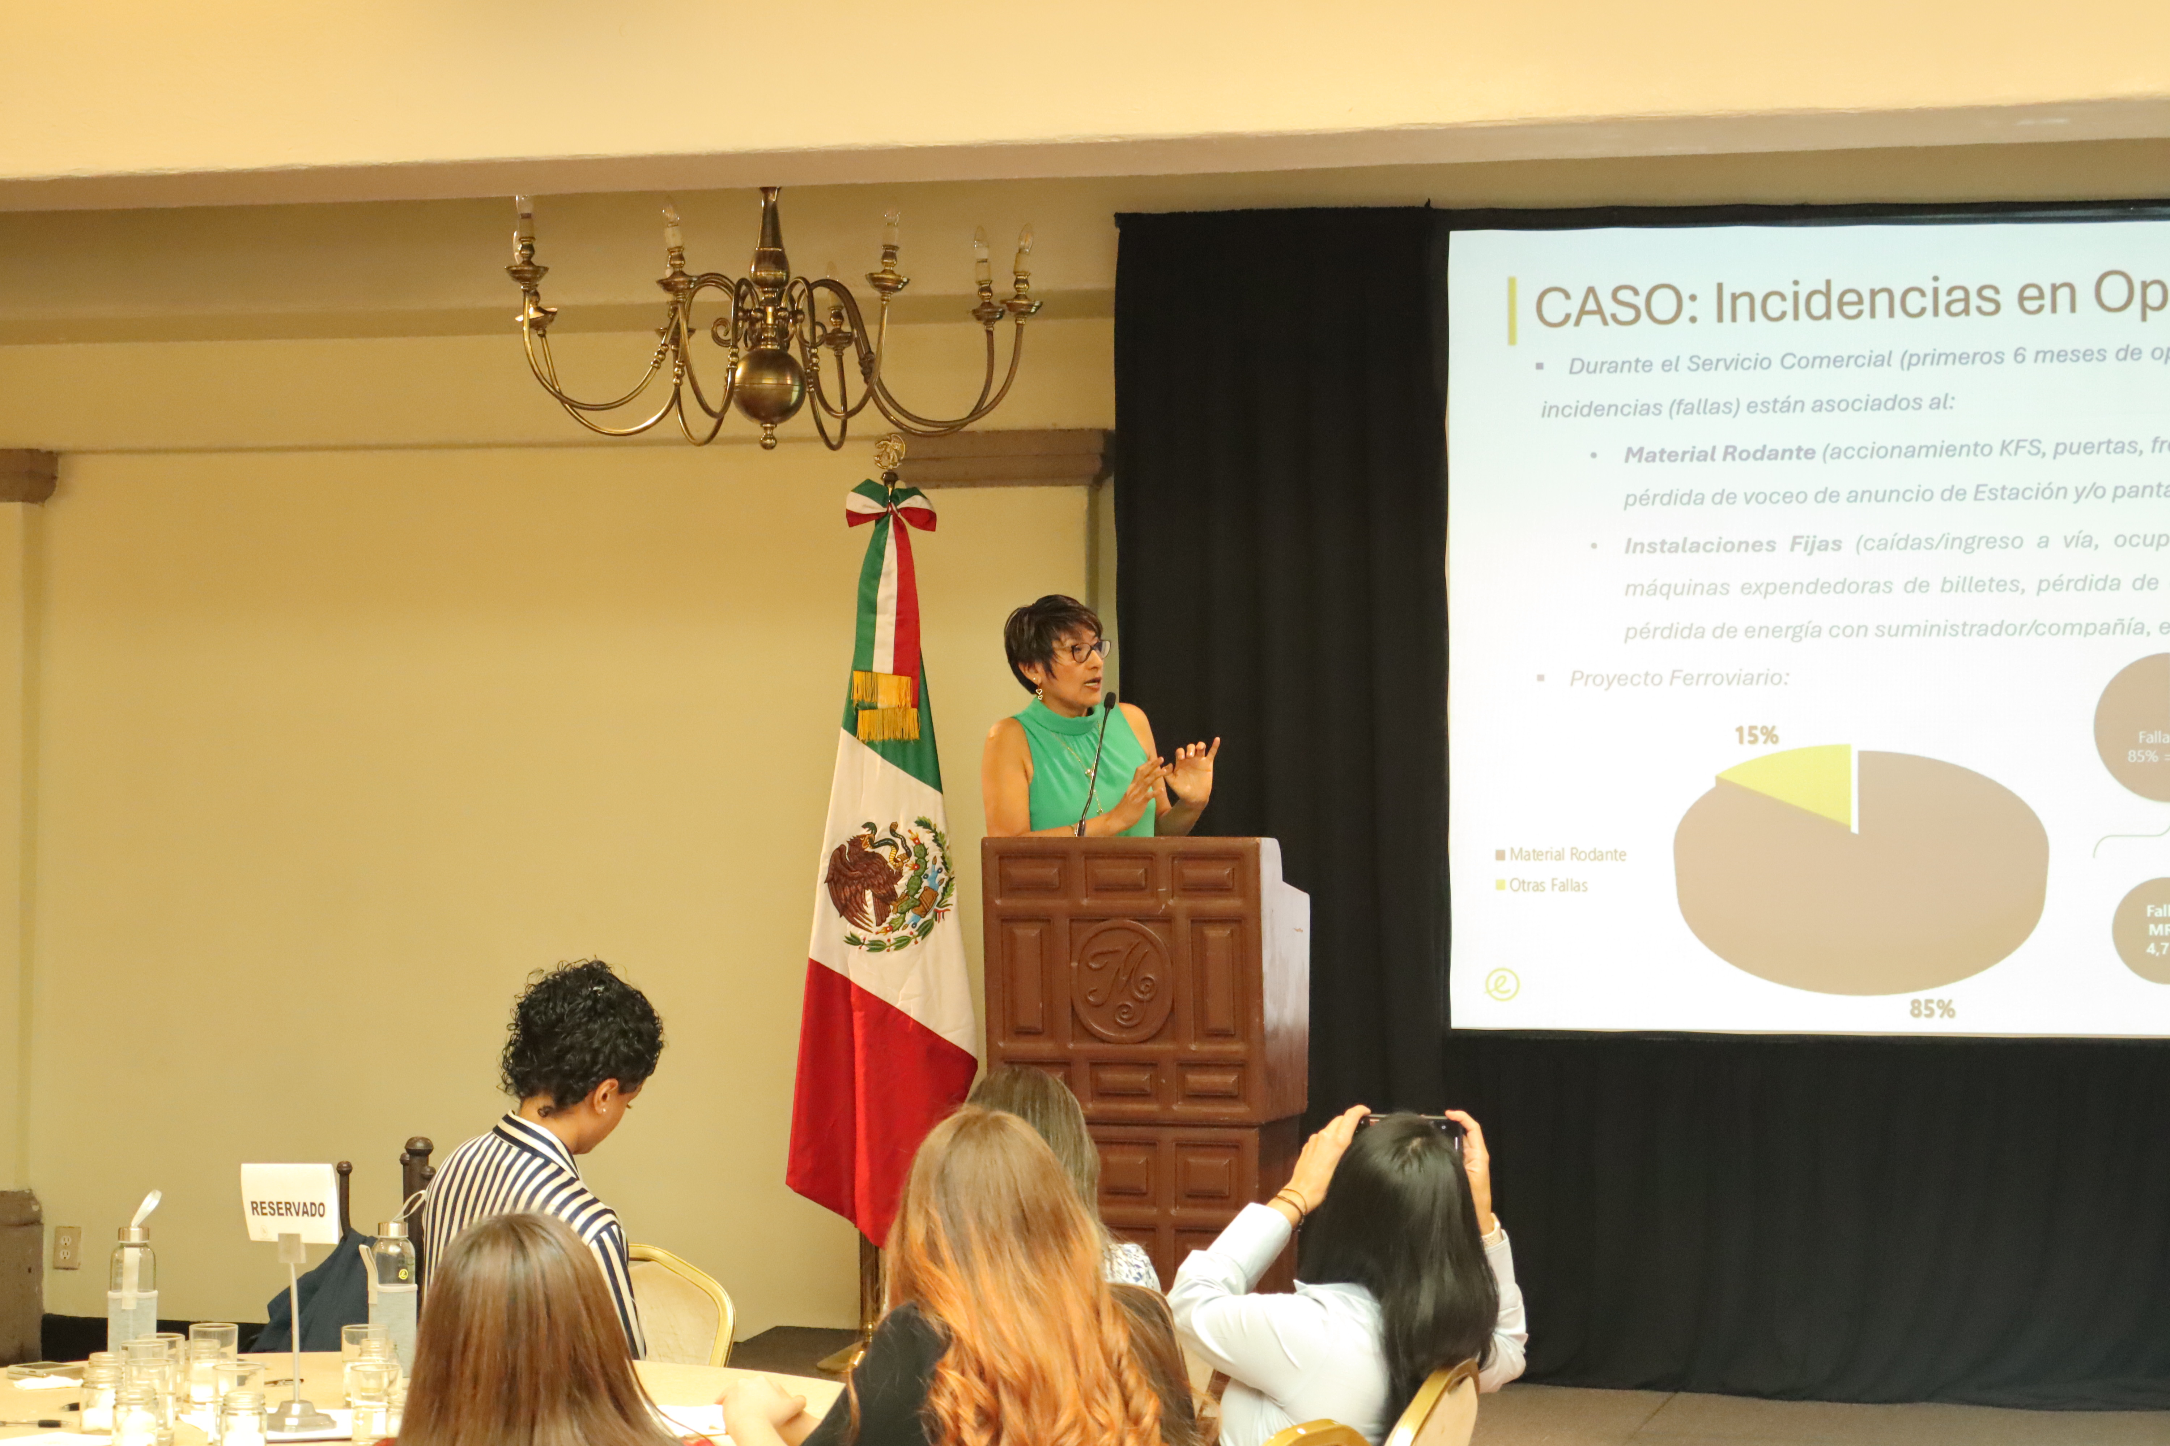
- The unified payment card, integrating metro, trolleybus, RTP, Metrobús, and other systems
She also shared insights from her experience on railway infrastructure, pointing out that 85% of incidents stem from rolling stock failures, while 15% are related to fixed structures, stressing the need for better maintenance and technological innovation in the sector.
"At Egis, we believe the future of railway mobility should be designed with social vision, accessibility, and scalability for users." – Yudi Monterroso

Breaking Paradigms and Paving the Way
Another inspiring moment was the presentation by Lorena León, who encouraged attendees to challenge limits and carve their own paths in the railway industry. Her motivational speech emphasized the importance of resilience, determination, and collaboration in creating meaningful change in the sector.
Strategic Connections for the Future of Rail

The event concluded with a Speed Networking session led by Geraldine López, AMF Communications Coordinator. Participants had the opportunity to expand their professional networks, identify new business opportunities, and strengthen their communication skills.
This activity not only fostered collaboration but also drove the formation of strategic alliances within the railway sector, reinforcing the importance of networking for professional growth and industry transformation.

More Women in Rail = More Innovation, More Inclusion, and More Sustainable Development
Egis will continue leading change, promoting collaboration networks, and supporting the professionals transforming the sector.
With talent, innovation, and a future-oriented vision, Egis reaffirms its commitment to a more equitable and competitive railway industry.

contacto.mexico@egis-group.com
www.egis-group.com https://www.linkedin.com/showcase/egis-en-latam/

About Egis
________________________________
 | 
Egis is an international player active in architecture, consulting, construction engineering and mobility services. We create and operate intelligent infrastructures and buildings that respond to the climate emergency and contribute to more balanced, sustainable and resilient territorial development.
Operating in 100 countries, Egis puts the expertise of its 19,500 employees at the service of its clients and develops cutting-edge innovations accessible to all projects. Through its wide range of activities, Egis is a key player in the collective organisation of society and the living environment of citizens all over the world.

Linkedin: Egis | Instagram: @egisgroup | X: @egis | Facebook: @egisgroup

Press contacts
________________________________

 | Celia Szymanski  Media Leader  TASCOMM  Tel: 55 5433 5072  cszymanski@tascomm.net | Karen Santamaria  Marketing & Communication Manager LatAm  Tel: +52 1 55 7974 9357  ana.santamaria@egis-group.com


