HALF YEARLY STATISTICAL SUMMARY
JAN-JUNE 2025 – CRIMINAL JUSTICE

overview

reports
An overall total of 222 reports (all types) were completed during the first half of 2025, representing a -4.3% decrease on 2024 (232 reports)

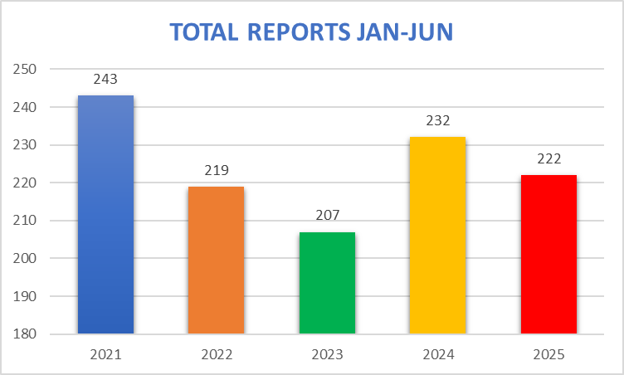

A detailed breakdown is given below.
 | Pre-Sentence Reports – Jan-Jun
Court | 2021 | 2022 | 2023 | 2024 | 2025 | % change on previous year
Youth | 23 | 17 | 16 | 19 | 10
Magistrate’s | 101 | 86 | 89 | 104 | 104
Royal | 43 | 40 | 30 | 31 | 44
Guernsey Court |  |  |  |  | 1
Total | 167 | 143 | 135 | 154 | 159 | 3.2%

Notes
- Of the 159 PSRs written 24 had a risk of DA
- 1 report was written for the Gsy Courts by a Jersey PO due to conflict of interest
- 1 adult appeared in the Royal Court on two separate occasions
- 3 adults had two PSRs written for separate offences

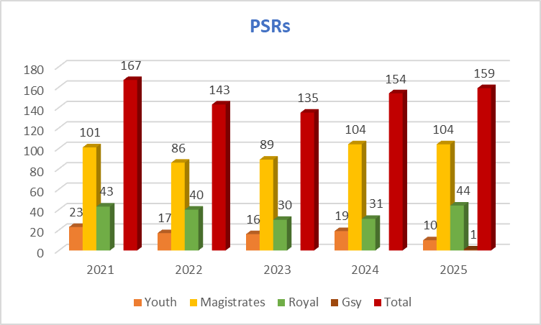

Stand-downs Jan-Jun
Court | 2021 | 2022 | 2023 | 2024 | 2025 | % change on previous year
Youth | 2 | 0 | 0 | 0 | 0
Magistrate’s | 18 | 25 | 21 | 18 | 10
Total | 20 | 25 | 21 | 18 | 10 | -44.4%

Other Reports Jan-Jun
Report type | 2021 | 2022 | 2023 | 2024 | 2025 | % change on previous year
Conditional Early Release | 5 | 3 | 18 | 16 | 16
Deportation | 4 | 4 | 7 | 5 | 8
Information for Court | 16 | 20 | 1 | 10 | 11
Sex Offender Notification | 3 | 9 | 4 | 2 | 9
Personal Information (for Youth Court) | 28 | 15 | 21 | 17 | 9
Total | 56 | 51 | 51 | 50 | 53 | 6%

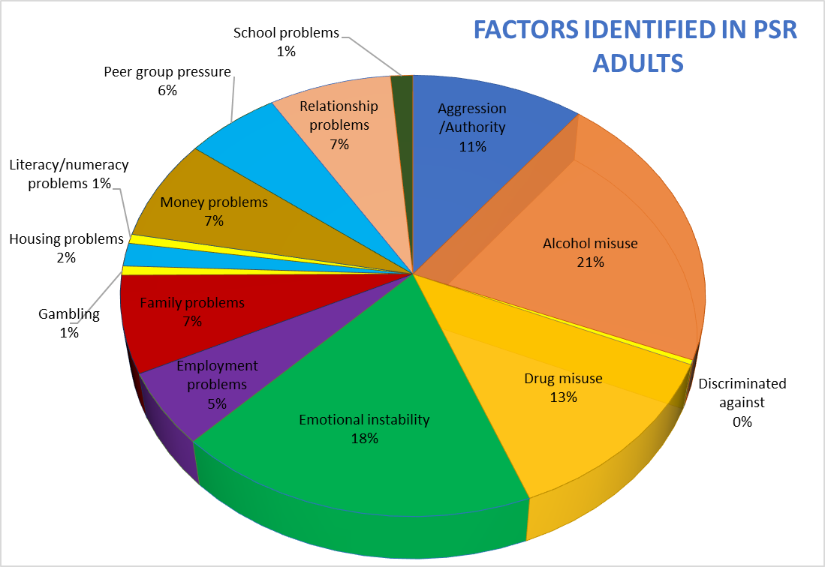

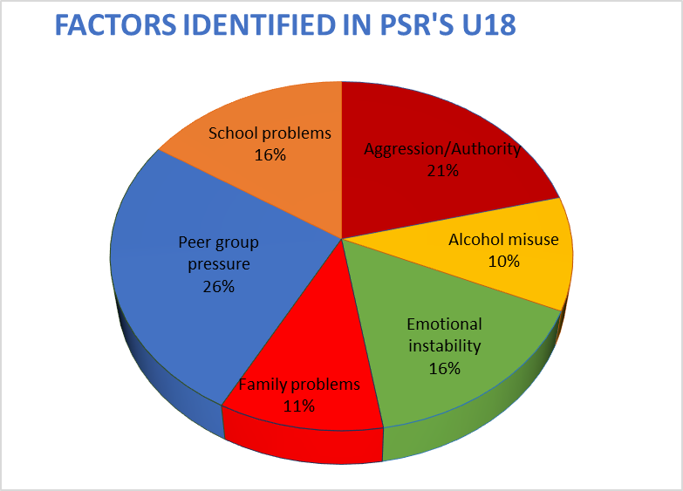

new supervisions – community & custodial

Jan-Jun 2024 – 245 Jan-Jun 2025 - 250

Children & Young People under 18 years - overall a 4.5% increase on 2024:

New Supervisions  Jan-Jun – UNDER 18s | 2021 | 2022 | 2023 | 2024 | 2025 | % change on previous year
Probation Order | 20 | 15 | 10 | 14 | 13
Community Service | 8 | 4 | 2 | 5 | 1
Custodial supervision (u.18) | 1 | 2 | 1 | 1 | 4
Bind Over Order | 4 | 3 | 5 | 0 | 2
Voluntary Supervision | 0 | 0 | 0 | 3 | 0
Parish Hall Voluntary Supervisions (Def Decs) | 18 | 15 | 25 | 21 | 26
Total | 51 | 39 | 43 | 44 | 46 | 4.5%

Notes:
- The U18 orders are made up of 43 individual young people.
- Two young persons had two Probation Orders, and one had three Probation Orders.
- One young person was placed on a Combination Order – Probation & Community Service.
- Parish Hall Voluntary Supervisions include all the deferred decisions (road safe, alcohol & drugs etc) allocated to a child.

Adults - Numbers have increased since 2024, showing a slight rise in community service orders and custodial supervisions. The probation orders have decreased from 2024 but remain in line with previous years.

New Supervisions | 2021 | 2022 | 2023 | 2024 | 2025 | % change
Jan-Jun – ADULT |  |  |  |  | 2025 | on previous year
Probation Order | 48 | 42 | 33 | 50 | 38
Community Service | 80 | 63 | 58 | 75 | 81
Custodial supervision | 49 | 61 | 45 | 63 | 69
Custodial sup (18-21) | 0 | 2 | 4 | 3 | 5
Life Imprisonment | 0 | 0 | 0 | 0 | 0
Bind Over Order | 1 | 0 | 0 | 0 | 0
Suspended Sentence Supervision Order | 0 | 1 | 0 | 0 | 2
Voluntary Supervision | 7 | 21 | 14 | 10 | 8
Parish Hall voluntary supervisions (def dec) | 9 | 5 | 2 | 0 | 2
Totals | 194 | 195 | 156 | 201 | 205 | 2.0%

Notes:
- The adult orders are made up of 173 individuals.
- One adult had 2 custodial supervisions during this period.
- 28 adults had a Combination Order.
- 1 adult had two Community Service Orders.
- Voluntary Supervisions (non- Parish Hall), include clients who wish to continue receiving assistance after completion of their orders, self-referrals or other agency referrals received. Of the 8 commenced between Jan-Jun, 2 were for the Building Healthy Relationships Programme.

community service orders – hours analysis
There has been a slight decrease in the number of hours worked so far this year, however the hours ordered remain the same as last year. The scheme provided 7173.5 hours of free work for the benefit of the Island.
G4S were employed to assist us with CS sessions, enabling us to hold more sessions and increase the clients on these sessions.

CS Orders – Jan-Jun | 2021 | 2022 | 2023 | 2024 | 2025 | % change  on previous year
Hours ordered | 10412 | 7710 | 7336 | 9435 | 9447
Hours worked | 7942 | 8299 | 5719 | 8735 | 7173.50
Average order length | 118 | 115 | 122 | 109.2 | 86.4 | -20.9%
risk/need profiles on new probation &
community service orders
The LS-CMI, a psychometric tool, is used to measure an individual’s level of risk of reconviction and criminogenic need:

 | Order type | Risk Band | Jan-Jun 2024 Adult | Jan-Jun 2025  Adult | Jan-Jun 2024 U18 | Jan-Jun 2025  U18
 | Probation | Low | 14.0% | 15.8% | 14.3% | 30.8%
 |  | Medium | 40.0% | 47.4% | 21.4% | 7.7%
 |  | High | 46.0% | 36.8% | 64.3% | 61.5%
 |  |  | 100% | 100% | 100% | 100%
 | Community Service | Low | 75.0% | 58.6% | 0% | -
 |  | Medium | 14.3% | 27.6% | 0% | -
 |  | High | 10.7% | 13.8% | 0% | -
 |  |  | 100% | 100% | 0% | -

risk of reconviction scores at
termination of probation orders
Target: At least 66% of clients to have reduced their risk of reconviction by the end of their probation order

Comparison is made between the LS/CMI score at the end of an individual’s Probation Order to that at the start. The 2025 ½ Yearly figures below are based on 47 terminated orders (34 Adult and 13 U18) across all risk bands (a small number of closed orders will be not applicable):

Score Change | 2021 | 2022 | 2023 | 2024 Adult | 2025  Adult | 2024 U18 | 2025  U18
Decrease % | 70% | 59.3% | 55% | 43.3% | 58.8% | 28.6% | 53.8%
Increase % | 22% | 31.4% | 20% | 29.7% | 5.9% | 14.3% | 15.4%
No change % | 8% | 9.3% | 25% | 27% | 35.3% | 57.1% | 30.8%

Notes:
There is a core group of YP involved in anti-social behaviour/drugs. A multi-agency approach across the Island is being looked at.

breaches
Breaches of Probation Orders have increased by 50% on this time last year with a significant increase on clients who reconvicted during their order and breached their order conditions.

Breach type/reason | Breaches of  Community Service Orders |  | Breaches of Probation Orders
 | Jan-Jun 2024 | Jan-Jun 2025 | Jan-Jun 2024 | Jan-Jun 2025
Reconvicted | 3 | 2 | 3 | 10
Breach of order conditions | 2 | 4 | 2 | 6
Failed to attend as requested | 7 | 5 | 8 | 5
Other reason | 0 | 1 | 1 | 0
Behaviour towards staff/group | 1 | 2 | 0 | 0
Totals | 13 | 14 | 14 | 21

Notes:
- One adult breached his PO & BOTO
- One adult breached his PO twice
- One youth breached two POs and a BOO during this period

completion of probation orders
Target: 75% of both Probation and Community Service Orders to successfully complete

46 orders were terminated this half year with the reasons being as follows:
 | Jan-Jun 2024 | % | Jan-Jun  2025 | %
Completed (expiry date reached) | 38 | 90.4% | 36 | 78.3%
Reconvicted – revoked & new order imposed |  |  | 3 | 6.5%
Reconvicted -revoked & resentenced | 2 | 4.8% | 4 | 8.7%
Failed to comply with requirements – revoked & resentenced |  |  | 2 | 4.3%
Failed to comply with requirements – order discharged
Order Revoked – other reason | 2 | 4.8%
Terminated Early – good progress |  |  | 1 | 2.2%
Total | 42 | 100% | 46 | 100%
Notes:
- Of the 46 completions:
- 15 were youths - 2 failed to comply and their order was revoked and resentenced, 1 reconvicted and their order was revoked and a new order imposed. The remainder completed their Order.
- Of the 32 adults, 2 reconvicted and were sent to custody, 3 reconvicted and were resentenced and 1 had their order terminated early for good progress. The remainder completed their Order.
completion of community service orders
53 orders were terminated this half year with the reasons being as follows:
 | Jan-Jun  2024 | % | Jan-Jun  2025 | %
CS hours completed | 68 | 91.9% | 46 | 86.8%
Reconvicted - revoked & new order imposed | 0 | 0% | 0 | 0%
Reconvicted – revoked and resentenced | 0 | 0% | 2 | 3.8%
Failed to comply with requirements – revoked & re-sentenced | 4 | 5.4% | 4 | 7.5%
Revoked other reason | 2 | 2.7% | 1 | 1.9%
Total | 74 | 100% | 53 | 100%
Notes
- One client completed two CS Orders during this period.
- One client had his order revoked as the original sentence was appealed for being too lenient. He was resentenced and send to custody.

parish hall supervisions – U18
Breakdown of Supervisions from Parish - these have increased by 33.3 on 2024:

Target: To divert children from court wherever possible
Supervision type: |  |  |  |  | 2025 | % change
Supervision type: | 2021 | 2022 | 2023 | 2024 | 2025 | on previous year
Deferred Decision | 0 | 0 | 0 | 1 | 0
Deferred decision with Restorative Justice | 8 | 5 | 5 | 9 | 12
Deferred decision with Voluntary Supervision | 4 | 1 | 1 | 2 | 0
Deferred decision with Alcohol & Drug Education | 7 | 1 | 11 | 1 | 5
Deferred decision with RoadSafe (new) | 0 | 8 | 10 | 8 | 11
Total | 19 | 15 | 27 | 21 | 28 | 33.3%
Notes:
Two supervisions were allocated to youths who were 18 at the time of offence, however were dealt with under the youth process

completions of deferred decisions
from parish hall
Target: 75% of children to successfully complete periods of supervision ordered by Centeniers

35 supervisions terminated this half year have done so successfully. One was terminated as a further offence was committed and all matters going to Youth Court.

 | Jan-Jun 2024 | % | Jan-Jun 2025 | %
Completed (expiry date reached) | 26 | 100% | 35 | 97.2%
Further Offence |  |  | 1 | 2.8%
Total | 26 | 100% | 36 | 100%

programme interventions
The following table details those programmes which ran over the year in either group settings or on a one-to-one basis:

Building Healthy Relationships Programme

The Building Healthy Relationships Programme (formerly Jersey Domestic Abuse Programme) was introduced in early 2021 replacing the ADAPT programme. It is delivered on a one-to-one basis by Probation Officers to their clients, with modules tailored to the individual case.
From Jan-Jun 2025, we received 22 referrals to the Programme
- 17 came via the Criminal Justice system
  - 5 were on a Probation Order
  - 6 were on a Combination Order
  - 2 were on Voluntary Supervision
  - 4 were in Custody
- 4 came from professional referrals
- 1 was a self-referral
Risk Factors
- All 22 clients had a risk of Domestic Abuse.
- 8 were high risk
- 12 were medium risk
- 2 were low risk
The chart below outlines the status of those clients who were referred.

Engage programme

Engage is a pre-cursor for change programme offered to clients who may not be suitable for the full BHR Programme
From Jan-Jun 2025, 8 clients were recommended by their Probation Officer to attend
- 1 was in Custody
- 2 were on a Probation Order
- 5 were on a Combination Order
The chart below outlines the status of those clients who were recommended to Engage.
Total Referred Jan-Jun 2025 | Active Clients | Completed | Part Way Through | In Triage | Assessed Not Suitable | Started Not Completed | Refused to Engage
8 | 6 | 0 | 6 | 1 | 0 | 1 | 0

risk of domestic abuse

There are currently 85 current clients on our system with a risk of DA. This includes clients currently under a supervision order, voluntary supervision, or referred onto the BHR Programme.
Domestic Abuse Clients - Risks & Registered
Clients with Risk of Domestic Abuse | 85
Risk of DA with a Restraining Order | 27
Risk of DA with a Domestic Abuse Protection Order | 6
Risk of DA with a Registered Domestic Abuse Offender | 3

restorative justice

The half-yearly summary shows Restorative Justice Officer involvement in relation to 13 clients across all supervision types. This includes assisting the Probation Team in other areas of client work during 2025, alongside RJ.

Restorative Justice referrals come from all areas including the Parish Hall, Youth Court and the Probation Officer.

Contact Type | Jan-Jun  2 025 | Notes
Referrals | 20 | The referrals came from :-  BOO via the courts -1  Parish hall Enquiries-13  Probation Order-2  Combined Order- 2  Custody-1  Community service-1
Office Visit | 22 | We had 22 office visits for 17 clients. These cover initial assessments for RJ suitability, discussing victim sessions and further sessions once on the RJ scheme
Face to Face Apology | 5 | Where the client meets the victim and with the guidance of the RJ Officer, offers an apology to the victim when appropriate.
Letters of Apology | 8 | A client writes a letter of apology to the victim where appropriate
Making Amends Actions | 6 | The client will undertake physical work to make good the damage done or general work to make amends for the crime.
RJ Reports | 8 | Reports written for the Court for the end of a Deferred Decision
Notes:
- It can take up to 5 months from the offence taking place to it reaching Parish Hall. This period of time is not always in the victim’s interest for the perpetrator to meet them for a face-to-face apology. Therefore, face to face apologies are not always appropriate, especially in assault cases.
- Making amends actions are not always possible due to a few issues with Health & Safety and insurance with youths under 16. We try to encourage them to do Positive Steps as an alternative.
- We had one BOO with RJ issued by the court.

positive steps

Positive Steps was introduced in late 2021 for young people. Sessions are undertaken with a variety of partner organisations, either as part of a Court Order or a general activity.
Our clients attended the food bank, boxing and Grow as part of their positive steps this half year.

Positive Steps Jan-Jun
No of Attendees  2024 | No of Attendees 2025
7 | 3

total caseload
As of 30 June 2025 (point in time), the total caseload stood at 393 cases, this included all active, commenced and terminated cases. Unfortunately, we have no data for the same quarter in 2023 as there was no-one in post at the time.

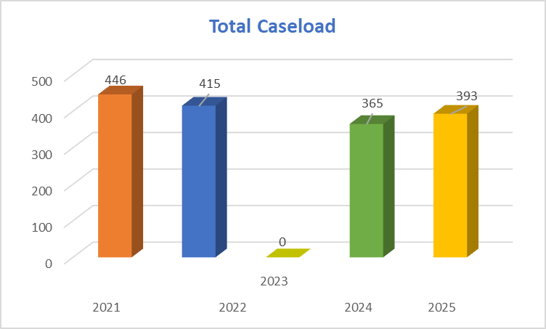

Notes
From the 393 cases
33 cases were for under 18s, representing 8.4% of the total caseload
40 cases were for under 21’s, representing 10.2% of the total caseload

half yearly statistical summary
jfcas
Overall caseload 78 – active cases as at 30/6/25
New cases added 65 – new events added onto our system during the year
New applications made 85
No of cases worked on 115

New Cases Added
Case type | 2021 | 2022 | 2023 | 2024 | 2025 | % change on previous Year
Adoption | 3 | 2 | 1 | 2 | 0
Private Law | 33 | 35 | 56 | 52 | 54
Public Law | 8 | 18 | 12 | 14 | 11
Total | 44 | 55 | 69 | 68 | 65 | -4.4%

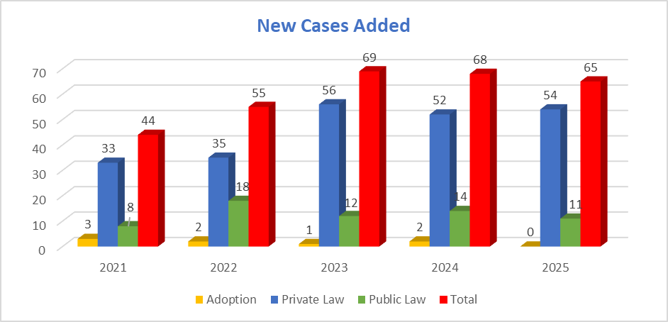
Notes:
Private Law now includes Family Foundation so figures will look considerably higher than previous years.

85 new applications were made, a 13.3% increase on 2024. An individual case may have several applications made within it:

 | 2021 | 2022 | 2023 | 2024 | 2025 | % change on previous year
No of Applications | 50 | 77 | 94 | 75 | 85 | 13.33%

