Contracting Agreement
governed by the AVA Zakelijk 2023
This contracting agreement is governed by the General Terms and Conditions Governing Contracting Agreements in the Construction Sector 2023 for business clients [Algemene Voorwaarden voor Aannemingen in het Bouwbedrijf 2023 voor de zakelijke opdrachtgever] (AVA Zakelijk 2023). An explanation of it may be sent to the client on request.

Quotation

Quotation number Quotation date
Client Contractor
Name: Name:
Address: Address:
Postcode: Postcode:
Place: Place:
Tel.: Tel.:
Email: Email:

hereinafter referred to as the “client” hereinafter referred to as the “contractor”
The contractor offers the following:

1. To perform the work referred to in §2 on the following parcel of land at the client's expense:
Address:
Place:
which is hereinafter referred to as the “work”.
2.In brief, the work shall entail the following:
[briefly describe the work: renovation, expansion, new construction, conversion, etc.]
3.The work shall be performed in accordance with the following drawing(s), technical description(s), designs, calculations and computation(s), being the following contract documents:
on,
on,
on,

4.[select one of the options and complete]
- The contract fee is:
Excluding VAT: €
VAT 9%
VAT 21%
Including VAT: €

The contract fee includes a sum of EUR ... for design work.

The contract fee includes the following gross/net [select one of the options] provisional items:
Description | Amount excluding VAT | Amount including VAT

- The price of the work is calculated on a cost-plus basis, with the contractor charging you for all costs incurred for the work.

The following rates are applied for own staff:
- Carpenter EUR per hour
- Etc.

The following rates are applied for equipment:
- Mobile crane EUR per hour
- Etc.

For general construction site costs EUR per day/week.
The contractor shall charge a surcharge on the costs incurred for
- Overheads:% on costs incurred
- Profit and risk:% on the sum of costs incurred and overheads
- CAR insurance:% on the sum of costs incurred, overheads, profit and risk
The sum of the costs incurred, overheads, profit and risk is increased by the turnover tax (VAT).

5. [select one of the options and complete]
- [contract fee]: The contractor shall charge you in instalments with multiple invoices. He sends the invoices at the following times:
- The first invoice for % of the contract fee following your instruction
- The second invoice for % of the contract fee if [describe the activities] have been completed
- The third invoice for % of the contract fee if [describe the activities] have been completed
- Etc.
- The last invoice % of the contract fee when the work is ready for handover.
- [cost-plus]: If the price is calculated on a cost-plus basis, the contractor shall regularly send an invoice for the costs incurred and not yet charged, plus surcharges and VAT (see 4).

6. Article 3 paragraph 1 letter a of AVA Zakelijk 2023 states that the client will provide the timely data and approvals required for the design of the work. If required, the client must also ensure timely construction notification and completion notification for the technical construction activity under the Building Quality Assurance Act.

7. [select one of the options and complete]
- The work commences within ___ working days after this agreement has been signed and received from the client.
- The work commences on or around ____________________________________(enter the day and date).
- The work start date is determined in consultation.

8. [select one of the options and complete]
- The work is handed over within working days after the start.
- The works is handed over on [enter date].
- The work handover date is determined in consultation.

9. [select one of the options and complete]
- If the work is handed over, the contractor shall not provide you with a handover file.
- If the work is handed over, the contractor shall provide you with a handover file within 3 months of handover. This file consists of:

[for example as-built drawings, construction calculations, materials list, description of the installations used, instructions for use and maintenance]

9. After a warning has been given in accordance with Article 4 paragraph 5 of the AVA Zakelijk 2023, the parties can consult about the possible consequences for the proper fulfilment of the agreement. This provision replaces Section 7:754, subsection 2 of the Dutch Civil Code.
10. The contractor’s liability after handover is governed by Articles 15.3 and 15.4 of the AVA Zakelijk 2023.. Paragraphs 1 and 2 of Article 15.3 expressly derogate from Section 7:758, subsection 4 of the Dutch Civil Code. Those paragraphs state the following:
"15.3 Liability after handover
1. After the day on which the work is deemed to have been handed over, the contractor will no longer be liable for defects in the work.
2. An exception applies to the provisions of the first paragraph if there is a defect:
a. that became apparent during the maintenance period and could not reasonably have been recognised by the client at the time of handover, unless the contractor demonstrates that the defect is to be attributed with a high degree of probability to a circumstance that can be attributed to the client;
b. that has become apparent after expiry of the maintenance period, which could not reasonably have been recognised by the client upon handover and in respect of which the client demonstrates that the defect must be attributed with a high degree of probability to a circumstance that can be attributed to the contractor."

11. This quotation and the agreement which is concluded upon its acceptance shall be governed by the General Terms and Conditions governing Contracting Agreements 2023 for business clients [Algemene Voorwaarden voor Aanneming van Werk 2023 voor de zakelijke opdrachtgever] (AVA Zakelijk 2023), drawn up by Bouwend Nederland. These terms and conditions are stated on the following pages and can be consulted on the contractor’s website: [insert the link]

Contractor’s signature:

Date:

The quotation is valid for 30 days from this date.

Acceptance

date

the client

name street
postcode place
hereby confirms – as set out in the aforementioned quotation – that it has awarded a contract to:

the contractor
name

to perform the work described above subject to the provisions of the AVA Zakelijk 2023.

The client hereby declares that they have received a copy of those terms and conditions or to have consulted them on the contractor’s website.

Client’s signature:

Date:

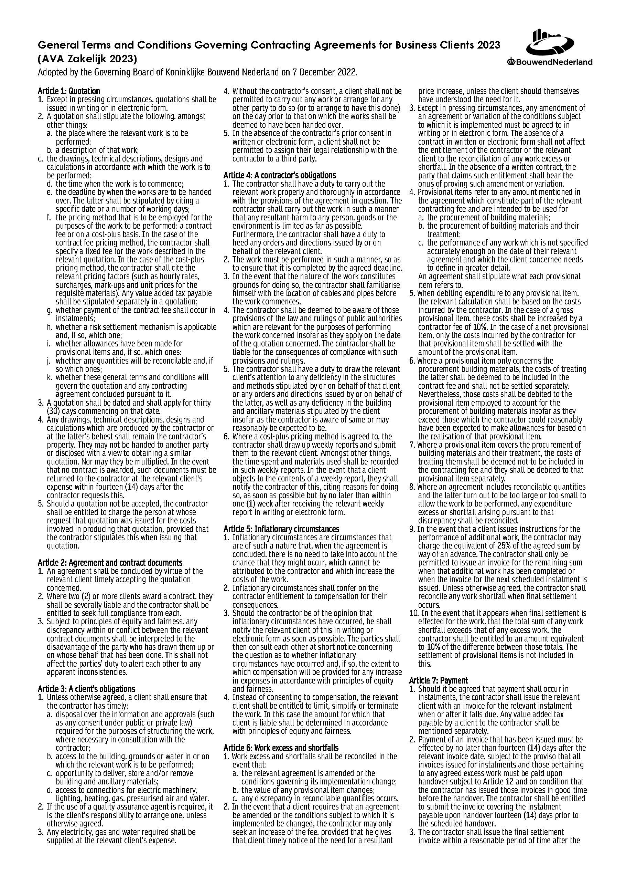

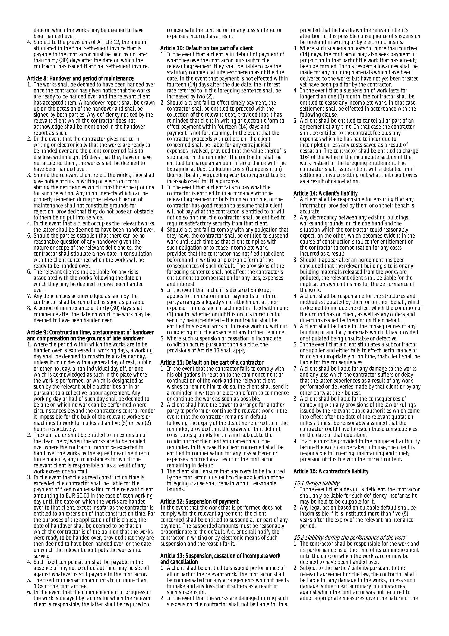

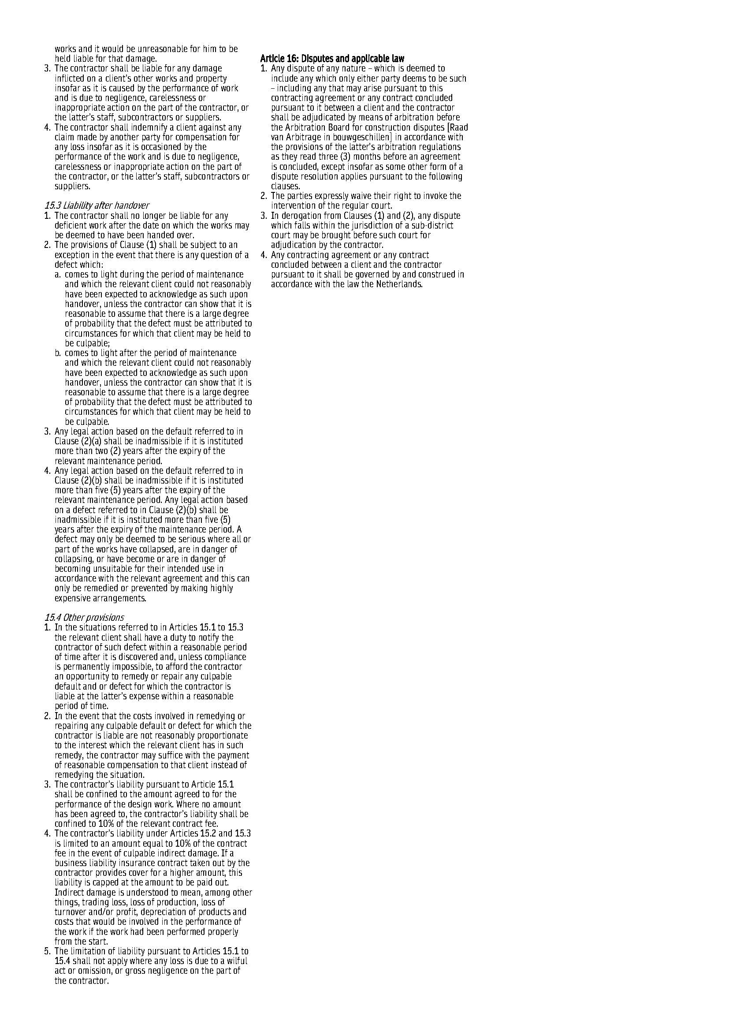

NB. The quotation and accompanying drawings, technical descriptions, designs and calculations which have been produced by the contractor or at the latter's behest shall remain the property of the contractor. They may not be handed to another party or disclosed with a view to obtaining a similar quotation. Neither may they be copied or replicated in any other way. In the event that no contract is awarded, such documents must be returned to the contractor at the relevant client's expense within fourteen (14) days after the contractor requests this.

