**Group Ticket Sales**

208 E Houston St

San Antonio, Tx 78205

(210) 226-5967

svillani@majesticempire.com

**Hi Group Leaders,**

Looking for the perfect outing? Below is the current list of events offering group discounts. This year we have Moulin Rouge! For 2 weeks, the best seating will be May 27- June 8**.** Our Special left for this year is *Mamma Mia!* So, it will have great seating for groups.

Please take note that seating will be **very limited** for: *Funny Girl* and *The Wiz*, so get your reservations in **ASAP**.

**Dean Z – The Ultimate Elvis Feb 22-23, 2025**

**Empire Theatre**

Whether you love the King of Rock & Roll or not, you’ve got to see Dean Z - The Ultimate Elvis! Dean Z's a tribute artist to Elvis and his performance will blow you away. With official endorsement from Elvis Presley Enterprises (EPE), his musical journey has been further enriched. In 2013, he clinched the prestigious [World’s Greatest Elvis Tribute Artists](https://www.bransontourismcenter.com/info/2013/08/18/legendary-dean-z-wins-ultimate-elvis-tribute-artist-contest/), a testament to his dedication and skill. When you visit this show, you'll get to hear classic songs from all of the different eras of Elvis' musical career. Dean Z's cast consists of 15 individuals including a dynamic rhythm section comprised of four musicians, a soulful horn section featuring four instrumentalists.

***Groups of 10 or more:*** Main Floor $77, $68, Crown Club $77 Mezzanine $59, $50, Balcony $41

***Funny Girl*** **2 hours 50 minutes**  **Feb 25-March 2, 2025**

**Majestic Theatre**

WELCOME TO MUSICAL COMEDY HEAVEN! Featuring one of the most iconic scores of all time by Jule Styne and Bob Merrill, an updated book from Harvey Fierstein based on the original classic by Isobel Lennart, tap choreography by Ayodele Casel, choreography by Ellenore Scott, and direction from Michael Mayer, this love letter to the theatre has the whole shebang!

The sensational Broadway revival dazzles with one of the most celebrated musical scores of all time, including classic songs “Don’t Rain on My Parade,” “I’m the Greatest Star,” and “People.” This bittersweet comedy is the story of the indomitable Fanny Brice, a girl from the Lower East Side who dreamed of a life on the stage. Everyone told her she’d never be a star, but then something funny happened—she became one of the most beloved performers in history, shining brighter than the brightest lights of Broadway.

**Recommended for 10 and up**

**\*Funny Girl**  **These Price will be going up, Your reservation locks in your Price**

**\*Student/Senior/Military Group Discounts**

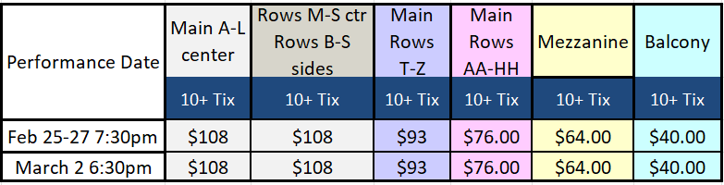

**Group Bundling approved for all shows except Sat Mat**

**1 Comp for every 40 paid tickets except Sat Mat**

***Naruto The Symphonic Experience March 5, 2025***

***Majestic Theatre***

NARUTO: The Symphonic Experience is a live concert that brings the beloved anime to life on a grand scale. This two-hour event features a film montage of iconic scenes from over 220 episodes, synchronized to a live orchestra performing Toshio Masuda's original score. Fans will relive Naruto Uzumaki's journey to become Hokage, facing rivalries, challenges, and growth along the way. The orchestra performs not only Masuda's unforgettable soundtrack but also the series' most famous openings and endings, inviting the audience to sing along with the music they love. This interactive element draws fans closer to Naruto, celebrating the powerful, shared bond the music creates. This event is truly exclusive: the film and musical montage created for NARUTO: The Symphonic Experience can only be seen at these shows. Audiences will have a unique opportunity to sing, laugh, cheer, and feel the excitement of seeing their favorite characters on screen, experiencing the full range of emotions that Naruto inspires. With Masuda's dynamic soundtrack, blending rock, pop, and traditional Japanese instruments like the Shakuhachi and Shamisen, the live music elevates each scene's impact, immersing the audience in Naruto's story.

**Groups of 10 or more:** Main Floor A-S$77, T-Z $59, AA-HH $23, Mezzanine $59, Balcony KK-MM $59, Rest of Balcony $41

***Blippi – Join the Band March 7, 2025***

***Majestic Theatre***

C'mon and join Blippi to make music in your hometown in the brand new live Blippi: Join the Band Tour! Blippi will be joined onstage by Meekah, their singing and dancing buddies and LIVE musicians to explore what makes music, including sounds, rhythms and instruments, through all your favorite

Blippi hits. So grab your drumsticks, tune up your guitar, and move those feet with Blippi and get ready for a musical performance that's fun for the whole family!

**Groups of 10 or more: Main Floor A-O $69.50, P-S $54.50, T-HH $44.50, Mezzanine $34.50**

**Pairs of Aisle Seats $10 additional**

***The Great Gatsby by The World Ballet Co. Runtime 2 hours March 12. 2025***

***Majestic Theatre***

Step into the jazzy world of the Roaring Twenties with this new production of the World Ballet Company. See the glitz, glamor, and tragic romance of F. Scott Fitzgerald’s timeless novel LIVE on stage, featuring a multinational cast of 40 professional ballet dancers, an all-star creative team, lustrous hand-crafted costumes, and lavish, groundbreaking sets. The original score evokes the energy and atmosphere of the 1920s.

**Groups of 10 or more: Main Floor $113, $86, $64.50, Mezzanine $113, $86, $64.50, $36.50**

**Rock Orchestra by Candlelight March 23, 2005**

**Majestic Theatre 7:30pm**

After mesmerizing audiences across Europe and the UK, The Rock Orchestra by Candlelight is set to electrify the USA once again. Prepare for a spellbinding 90-minute spectacle that infuses iconic Rock & Metal anthems with a hauntingly beautiful energy. In ethereal candlelit settings, this band of 14 classical musicians unleash effortlessly enchanting melodies alongside powerful walls of distortion. Witness the unexpected union of Classical music and Metal. Performing the music of iconic bands

including Metallica, AC/DC, Rolling Stones, Pantera, My Chemical Romance, Linkin' Park, SOAD, Guns N Roses, Evanescence, Papa Roach, The Cranberries & MORE!

**Groups of 10 or more:** Main Floor A-Z **SOLD OUT**, AA-HH $65.30 Mezzanine **SOLD OUT** Balcony **SOLD OUT**

***A Man Named Cash March 28, 2025***

***Empire Theatre 7:30pm***

Featuring vocalist Eric Hofmanis, who was personally selected by The Johnny Cash Estate and John Carter Cash (Johnny Cash's son) to be the lead vocalist for the acclaimed 2023-24 Johnny Cash The Official Concert Experience 100 city National tour. A Man Named Cash is fully live, high energy and unforgettable show that takes you on a thrilling and comprehensive journey through the iconic music and enduring legacy of Johnny Cash. Recognized by fans as one of the most honest and true representations of Johnny Cash live in concert, Eric's deeply resonant voice and profound embodiment of Cash's spirit will leave you captivated as he performs an eclectic range of hits including, I Walk The Line, Ring Of Fire, Sunday Morning Coming Down and the 2004 Grammy Award winning Hurt. Eric is joined onstage by Megan Houde as June Carter, whose vibrant presence brings a perfect balance of joy, love, and tenderness to the performance. Their remarkable onstage chemistry, reminiscent of Cash and Carter themselves, promises an unforgettable experience that will leave you enchanted and uplifted as they perform such as hits as Jackson and It Ain't Me, Babe and many more!

Groups of 10 or more: Main Floor **Sold Out** Crown Club **Sold Out**, Mezzanine $44.55, $35.55

***Mamma Mia!* (Special)** Runtime 2 hours 35 min **April 1-6, 2025**

**Majestic Theatre**

A mother. A daughter. 3 possible dads. And a trip down the aisle you’ll never forget!

Set on a Greek island paradise where the sun always shines, a tale of love, friendship, and identity is beautifully told through the timeless hits of ABBA. On the eve of her wedding, a daughter’s quest to discover the father she’s never known brings three men from her mother’s past back to the island they last visited decades ago. For nearly 25 years, people all around the world have fallen in love with the characters, the story, and the music that make MAMMA MIA! the ultimate feel-good show.

***Mamma Mia!***

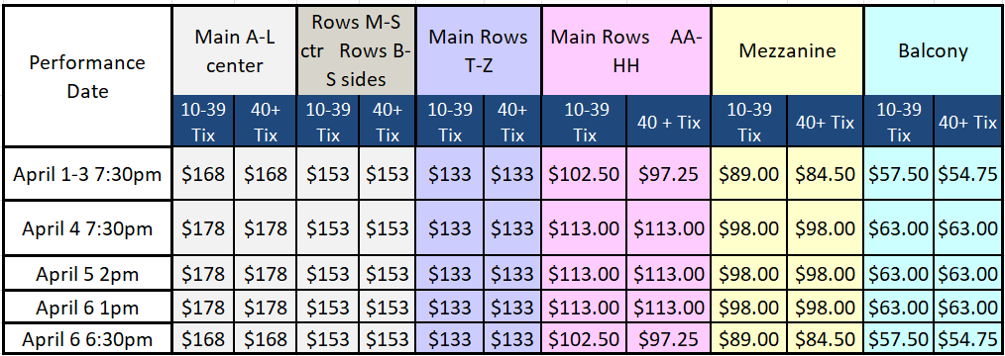

**\*Student/Senior/Military Group Discounts**

**Group Bundling approved for All Show except Sat/Sun Mat**

**1 Comp for every 40 paid tickets, except for Sat/Sun Mat**

***Disney on Ice April 17-20, 2025***

***Alamodome***

Mickey and his pals are rocking the DJ table as they remix Disney tunes into colorful worlds. Wish upon a star with Asha and Valentino, roar with delight at Timon and Pumbaa, and groove to ocean beats with Ariel and friends. Harmonize with Elsa and Anna, sway to the rhythm of the waves with Moana,

and join the party when Stitch takes control. Get ready to turn up the fun at Disney On Ice presents Let’s Dance!

**Showtimes: Thu 7pm, Fri (Good Fri) 1pm 7pm Sat 11am/3pm/7pm Sun 3pm**

**Groups of 10 or More: Floor $141.81, $82.28. Plaza Level $50.88, $46.55, $38.98, $28.15, $22.74**

***The Wiz***  **2 hours 20 minutes** **May 6-11, 2025**

**Majestic Theatre**

**Everybody Rejoice! The Tony Award-winning musical *THE WIZ* is coming to San Antonio!** This groundbreaking twist on *The Wizard of Oz* changed the face of Broadway—from its iconic score packed with soul, gospel, rock, and finger-snapping 70s funk to its stirring tale of Dorothy’s journey to find her place in a contemporary world.  Audiences get to enjoy the epic grooves of such beloved, timeless hits as “Ease on Down the Road,” which became the show’s break-out single, and the bona fide classic “Home” in this spectacular revival. A dynamite infusion of ballet, jazz, and modern pop brings a whole new groove to easing on down the road. So everybody rejoice! An all-new 21st-Century WIZ is sliding into an Emerald City near you.

***The Wiz*** **These Price will be going up, Your reservation locks in your Price**

**\*Student/Senior/Military Group Discounts**

**Group Bundling for all shows except Sat Mat**

**1 Comp for every 40 paid tickets, excluding Sat Mat**

**Couture on Tour – An Emily in Paris Experience May 19, 2025**

**Majestic Theatre**

Step into the enchanting world of Emily In Paris, where every corner brims with elegance and allure. Begin with a cinematic journey into haute couture, then revel in a spectacular stage show featuring iconic designs in collaboration with Costume Designer Marylin Fitoussi. Stroll through interactive exhibits, shop exclusive merchandise, and capture picture-perfect moments in Parisian-inspired settings. Experience the romance of fashion, the thrill of artistry, and the magic of Paris.

**Group of 10 or more:** Main Floor H-O $89.55, P-S $71.55, T-HH $53.55, Mezzanine $35.55

**Pair of Aisle seats are $9 more per ticket.**

***Moulin Rouge! The Musical*** **May 27-June 8, 2025**

**Majestic Theatre**

Pop the champagne, *Moulin Rouge!* *The Musical* is the winner of 10 Tony Awards®—including Best Musical!

Enter a world of splendor and romance, of eye-popping excess, of glitz, grandeur, and glory! Baz Luhrmann’s revolutionary film comes to life onstage, remixed in a new musical mash-up extravaganza.

Set in Paris 1899, a world of indulgent beauty and unparalleled extravagance, of Bohemians and aristocrats, of boulevardiers and reprobates, Moulin Rouge! The Musical is the story of a lovesick American writer, Christian, and Satine, the dazzling star of the Moulin Rouge nightclub. When their lives collide at the Moulin Rouge, they

fall hopelessly in love, only to be thwarted by the nightclub’s host and impresario, Harold Zidler, and the Duke of Monroth, the wealthy and entitled patron of the club who thinks he can buy anything he wants...including Satine. **Study Guide is available.**

*Moulin Rouge! The Musical* contains some mature themes, revealing costumes and adult language.

***Moulin Rouge!* Week 1** **These Price will be going up, Your reservation locks in your Price**

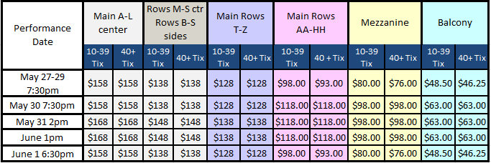

***Moulin Rouge!* Week 2**

**\*Student/Senior/Military Group Discounts**

**Group Bundling for all shows except Sat Eve**